Assignment 1

Ans1: Frontend: It is the visual and interactive part of website.
It is used to build responsive, visually appealing user interface and convert designs from Figma into code.
Real-World Example:
When you open YouTube
- The video player,
- The search bar,
- The like/dislike buttons,
- The comments section,
All of these are part of the frontend.

Backend: It is server-side operations and databases.
It is used to handle authentication, authorization, and security.
Real-World Example:
When you log in to Instagram
- The backend checks if your username and password match.
- It fetches your posts, followers, and likes from the database.
- It also saves any new photos or messages you send.
All this data processing happens in the backend, which users cannot see.

Full-Stack: It is the combination of both frontend and backend. Used to build end to end solutions.
Real-World Example:
Imagine you’re building an Online Food Ordering Website like Zomato:
- Frontend: Displays restaurant lists, menus, and order buttons.
- Backend: Stores restaurant data, user details, and manages orders.
- A Full-Stack Developer can build both parts and make them work together —
so when you click “Order Now”, the data is sent to the backend and stored in the database.
Ans2: 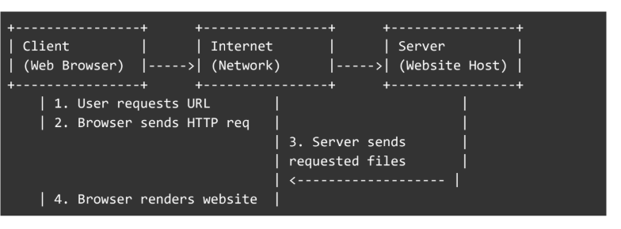

Ans3: 1- User types a URL in the browser.
2- The browser contacts the DNS to get the server’s IP address.
3-It sends an HTTP/HTTPS request to the web server.
4-The server processes the request and sends back HTML, CSS, and JS files.
5-The browser renders these files and displays the web page to the user.

Ans4: Tools for Web Development Environment:
- Code Editor (VS Code): For writing and editing code.
- Web Browser (Chrome/Firefox): To view and test web pages.
- Version Control (Git/GitHub): To save and manage code versions.
- Node.js & npm: To run JavaScript and install packages.
- Local Server (Live Server): To test websites locally.

Ans5: A web server is software or hardware that stores and delivers web pages to users through a browser using HTTP/HTTPS.
Examples:
- Apache
- Nginx
- Microsoft IIS
- LiteSpeed
- Node.js

Ans6: Roles in a Web Development Project
- Frontend Developer: Designs and builds the user interface using HTML, CSS, and JavaScript. Ensures the website is responsive, interactive, and user-friendly.
- Backend Developer: Manages the server, application logic, and database connections. Handles data processing, authentication, and API creation.
- Database Administrator (DBA): Designs, manages, and secures the database. Ensures data integrity, backups, and efficient data retrieval.

Ans7: 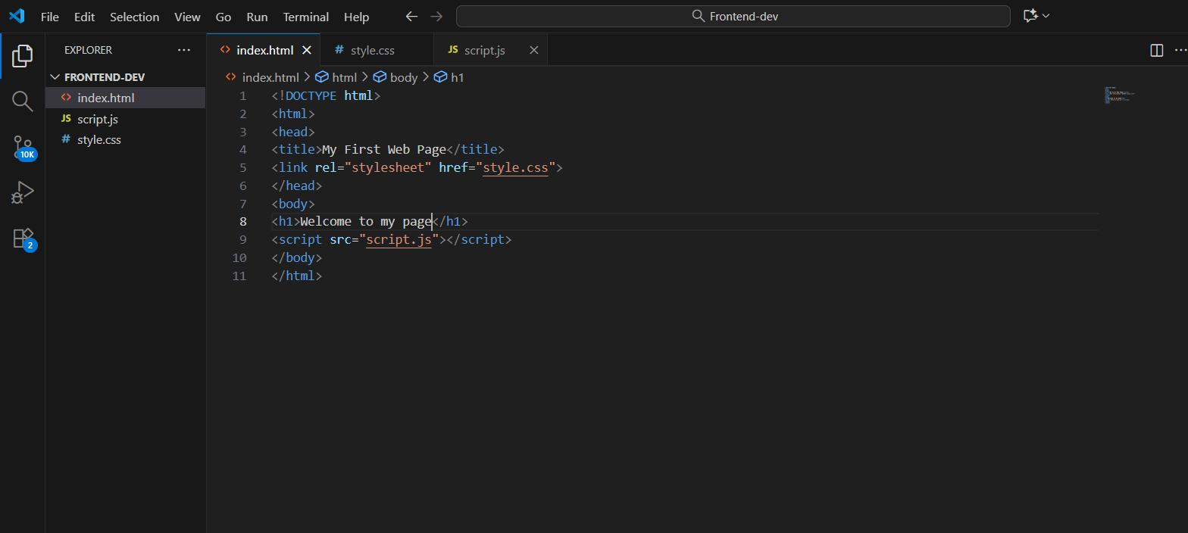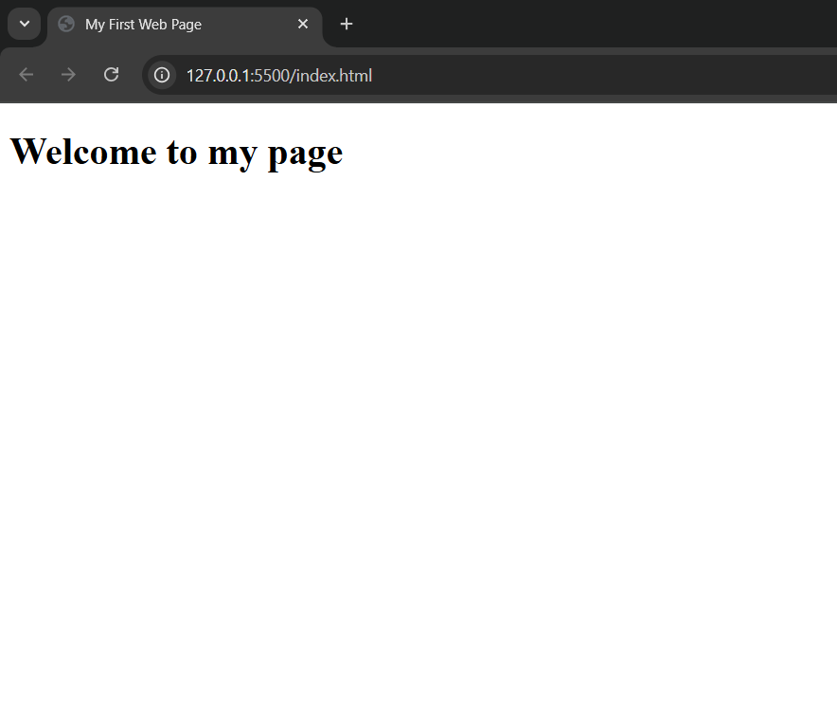
Ans8: A static website is a site with fixed content that does not change for different users. It is usually built using HTML, CSS, and JavaScript only, and does not require a database. Static websites are fast to load but harder to update, for example, a company’s portfolio site. On the other hand, a dynamic website displays content that changes based on user interaction or data from a database. It uses backend technologies like PHP, Node.js, or Python, making it easier to update and interactive, for example, Facebook or Amazon.

Ans9: Five popular web browsers are Google Chrome, Mozilla Firefox, Microsoft Edge, Safari, and Opera. Each uses a different rendering engine to display web pages: Chrome, Edge, and Opera use Blink, Firefox uses Gecko, and Safari uses WebKit. Rendering engines interpret HTML, CSS, and JavaScript, so differences in engines can slightly affect how websites look and perform across browsers.

Ans10: 